1. - Please aware following libraries are necessary to run the Python codes. For more details, please refer to the Anaconda installation guide in section III).

matplotlib pydot scikit-learn pandas openpyxl xlrd seaborn

* **PLEASE use Tensorflow V1.x or above** .
* REMEMBER to set you path at my sourceCode folder or copy the data files to your folder path when you run the Python. I changed the image data files names for easy of handling.

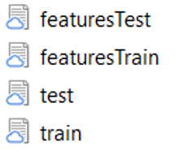

* You can change the level of display detail during Tensorflow Keras training by the API variable “verbose” by setting it to 0,1,2. Where 0 means not display at all.

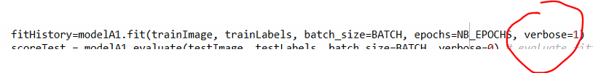

* Please feel free to contact me for any questions by 852-92292831 or [hoson@live.hk](mailto:hoson@live.hk) .

Screenshots –

The new named files in the folder sourceCodes:

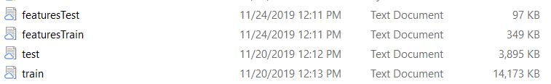

Addition Python tools:

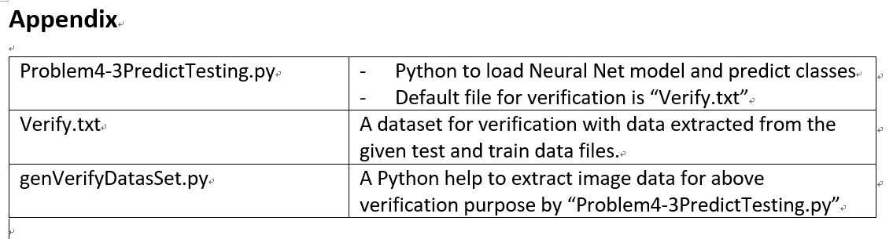

Verify.txt data file format is same as the original image data file format <Digits X>,<pixel 1>, ….<pixel 256> .

My Tensorflow Keras and Python versions for reference only:

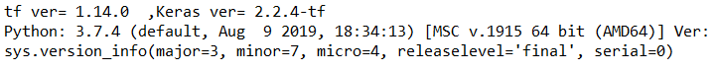

III)

""" Anaconda Installation Steps """" .

======================================

IDE and Python Spyder Installation Guide

1. Download Anaconda from: <https://www.anaconda.com/download/>
2. Download Tensorflow 1.x from: <https://anaconda.org/conda-forge/tensorflow>

2) Install all libraries under the INSTALLED envirnoment. e.g. (base)C:\Users\Admin>, [ drive name may be different ]

> conda install -c conda-forge matplotlib

> conda install -c anaconda pydot scikit-learn pandas openpyxl xlrd seaborn

Screenshots:

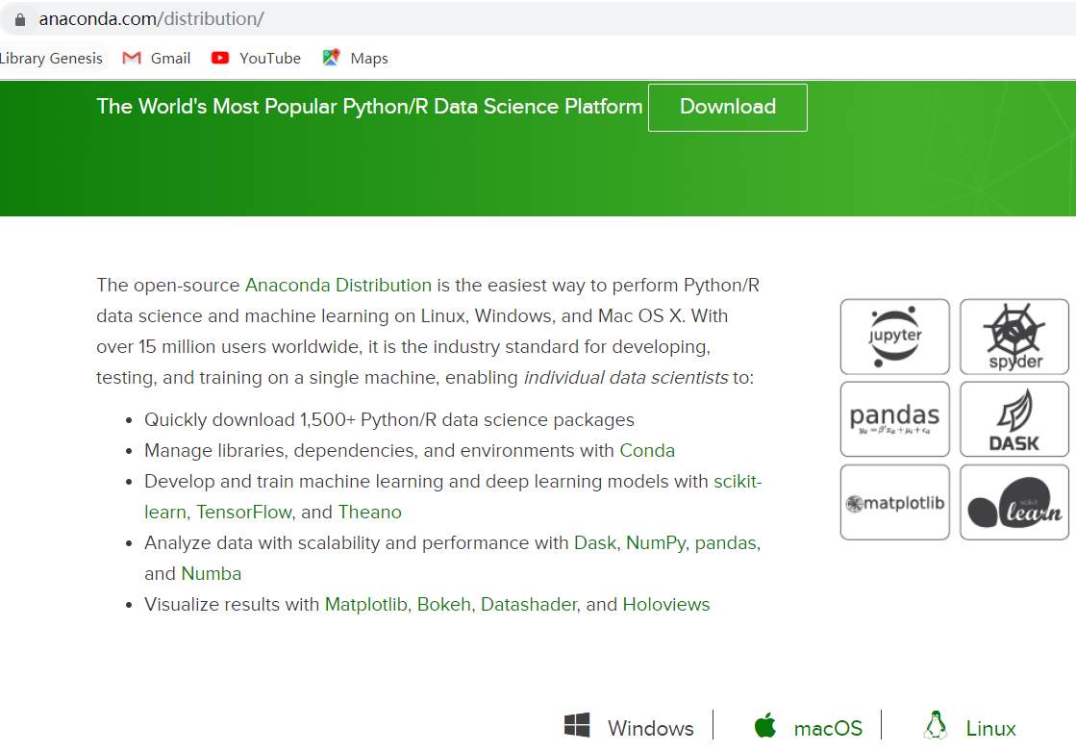

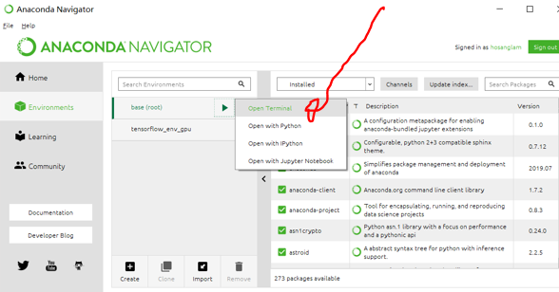

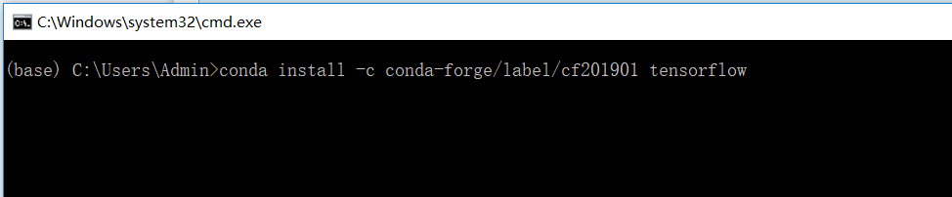

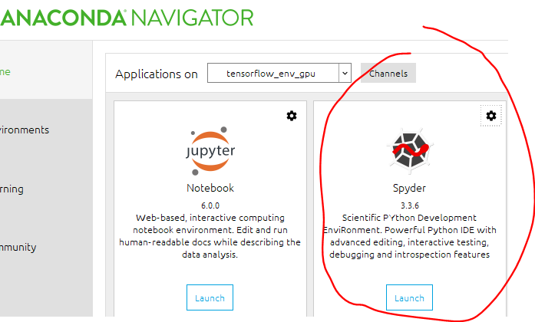

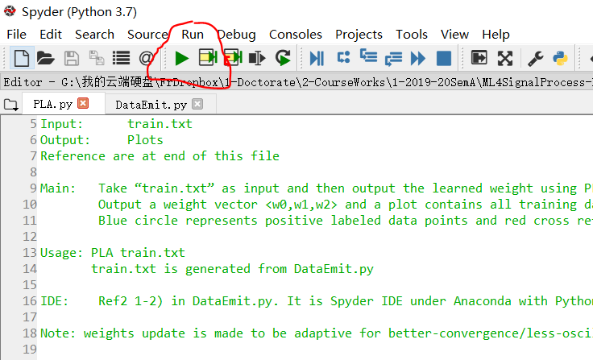

**\*\*\***

IF MUST USE TF2.0, replace all imports from “tensorflow” to “tensorflow.compat.v1” and put tf.disable statement as the last statement as shown below:

import tensorflow.compat.v1 as tf

from tensorflow.compat.v1.keras import layers

from tensorflow.compat.v1.keras.utils import plot_model, to_categorical

tf.disable_v2_behavior()